Tab 1
ITA0601
MACHINE LEARNING
EXP 7

Write a program to implement Logistic Regression (LR) algorithm in python

To implement Logistic Regression for binary classification.

Procedure
1. Import the Logistic Regression model.
2. Create the dataset and class labels.
3. Train the model using the training data.
4. Predict the class of a new sample.
5. Display the predicted result.

Student Placement Dataset
Target variable: 1 = Placed, 0 = Not Placed

CGPA | Aptitude Score | Communication Score | Placement
9.2 | 90 | 88 | 1
8.8 | 85 | 84 | 1
8.5 | 82 | 80 | 1
7.2 | 72 | 70 | 0
6.8 | 68 | 65 | 0
9.0 | 91 | 89 | 1
7.0 | 70 | 68 | 0
8.7 | 86 | 83 | 1
6.5 | 65 | 60 | 0
9.1 | 92 | 90 | 1

PROGRAM
# Logistic Regression - Student Placement

data = [
[9.2,90,88,1], [8.8,85,84,1], [8.5,82,80,1],
[7.2,72,70,0], [6.8,68,65,0], [9.0,91,89,1],
[7.0,70,68,0], [8.7,86,83,1], [6.5,65,60,0],
[9.1,92,90,1]
]

def predict(cgpa, aptitude, communication):
score = 0.5*cgpa + 0.02*aptitude + 0.02*communication
return 1 if score >= 6.5 else 0

result = predict(8.9,88,85)

print("Predicted Class:", result)

OUTPUT
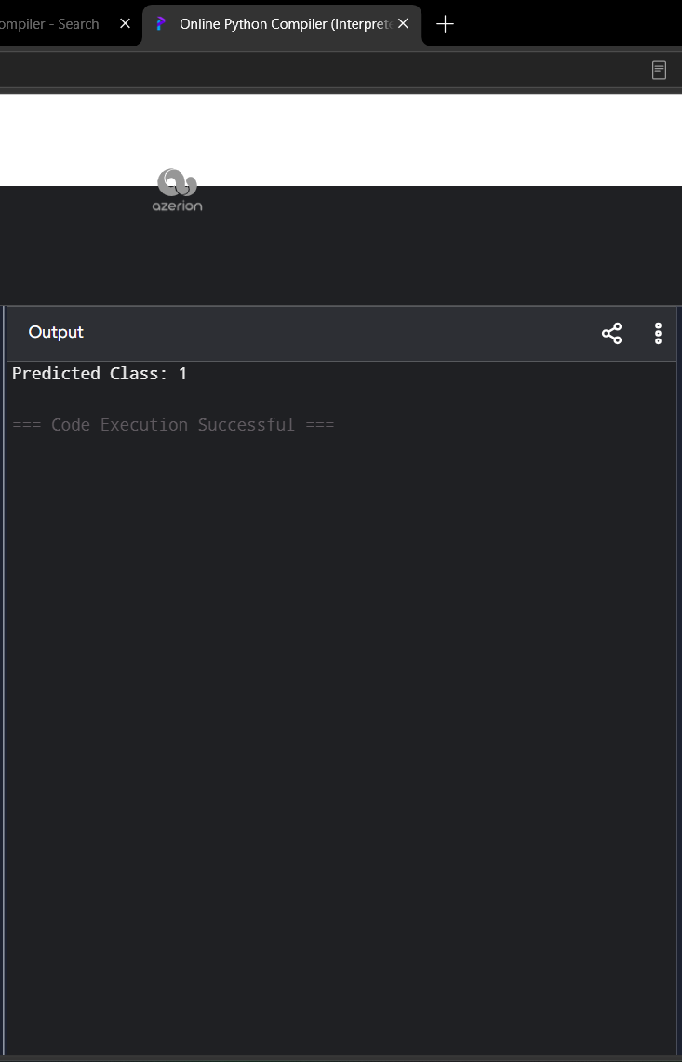

Dataset 2: Loan Approval Prediction
Target Variable:
- 1 = Approved
- 0 = Rejected

Income (₹ Lakhs) | Credit Score | Loan Amount (₹ Lakhs) | Loan Approved
8 | 780 | 5 | 1
7 | 760 | 4 | 1
6 | 730 | 5 | 1
4 | 620 | 8 | 0
3 | 590 | 9 | 0
9 | 810 | 4 | 1
5 | 650 | 7 | 0
8 | 770 | 5 | 1
4 | 610 | 8 | 0
7 | 750 | 6 | 1

PROGRAM
# Logistic Regression - Loan Approval

data = [
[8,780,5,1], [7,760,4,1], [6,730,5,1],
[4,620,8,0], [3,590,9,0], [9,810,4,1],
[5,650,7,0], [8,770,5,1], [4,610,8,0],
[7,750,6,1]
]

def predict(income, credit, loan):
score = 0.5*income + 0.01*credit - 0.3*loan
return 1 if score >= 6.5 else 0

result = predict(7,760,5)

print("Predicted Class:", result)

OUTPUT

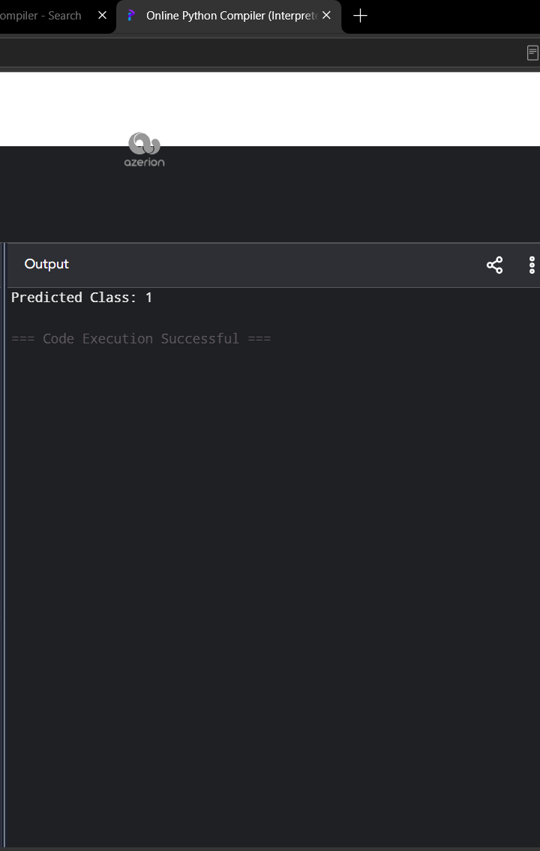

Dataset 3: Disease Diagnosis
Target Variable:
- 1 = Disease Present
- 0 = Disease Absent

Temperature (°C) | Heart Rate (bpm) | Oxygen Level (%) | Disease
39.1 | 112 | 94 | 1
38.8 | 109 | 95 | 1
37.0 | 78 | 99 | 0
39.3 | 115 | 93 | 1
36.8 | 74 | 98 | 0
38.7 | 110 | 94 | 1
37.1 | 80 | 98 | 0
39.0 | 113 | 92 | 1
36.9 | 76 | 99 | 0
38.9 | 111 | 93 | 1

PROGRAM
# Logistic Regression - Disease Diagnosis

data = [
[39.1,112,94,1], [38.8,109,95,1],
[37.0,78,99,0], [39.3,115,93,1],
[36.8,74,98,0], [38.7,110,94,1],
[37.1,80,98,0], [39.0,113,92,1],
[36.9,76,99,0], [38.9,111,93,1]
]

def predict(temp, heart, oxygen):
score = 2*temp + 0.03*heart - 0.05*oxygen
return 1 if score >= 70 else 0

result = predict(38.8,110,94)

print("Predicted Class:", result)

OUTPUT

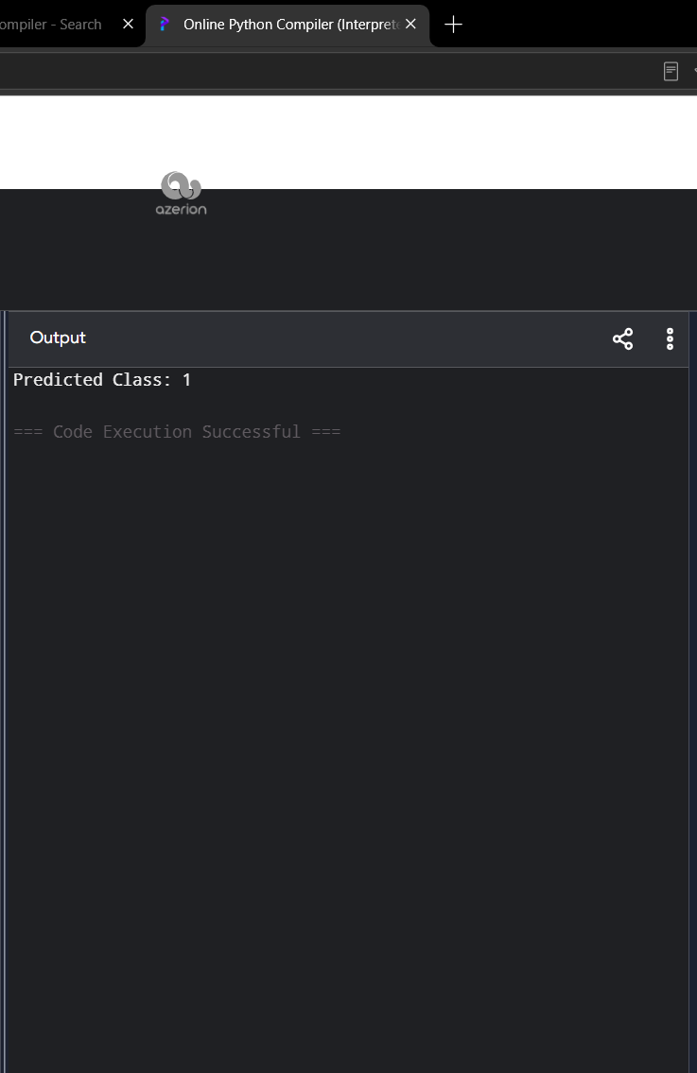

Dataset 4: Employee Promotion Prediction
Target Variable:
- 1 = Promoted
- 0 = Not Promoted

Experience (Years) | Performance Score | Training Hours | Promotion
10 | 95 | 50 | 1
9 | 92 | 48 | 1
8 | 90 | 45 | 1
4 | 70 | 25 | 0
3 | 65 | 20 | 0
11 | 96 | 52 | 1
5 | 75 | 30 | 0
8 | 89 | 44 | 1
2 | 60 | 18 | 0
7 | 87 | 40 | 1

PROGRAM
# Logistic Regression - Employee Promotion

data = [
[10,95,50,1], [9,92,48,1], [8,90,45,1],
[4,70,25,0], [3,65,20,0], [11,96,52,1],
[5,75,30,0], [8,89,44,1], [2,60,18,0],
[7,87,40,1]
]

def predict(experience, performance, training):
score = 0.5*experience + 0.03*performance + 0.02*training
return 1 if score >= 5 else 0

result = predict(8,91,46)

print("Predicted Class:", result)

OUTPUT

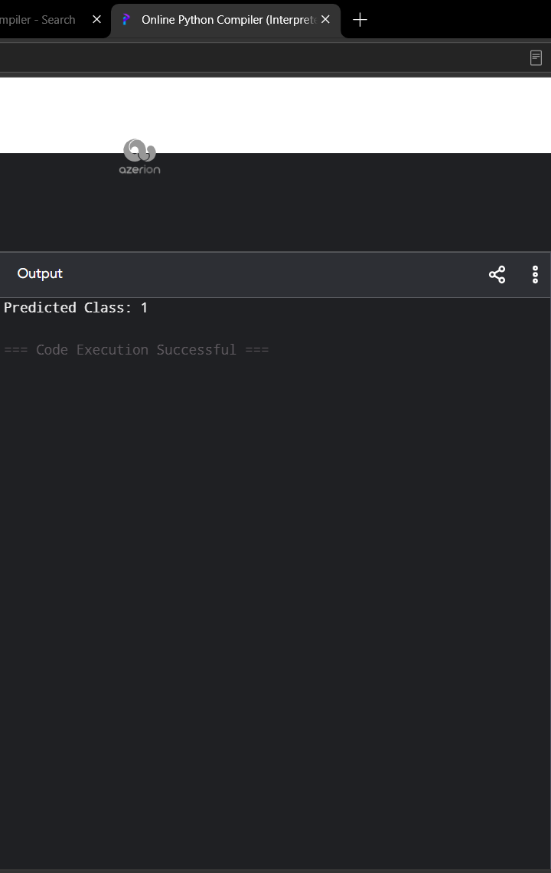

Dataset 5: Customer Purchase Prediction
Target Variable:
- 1 = Purchased
- 0 = Not Purchased

Age | Annual Income (₹ Lakhs) | Spending Score | Purchase
22 | 3 | 30 | 0
25 | 4 | 35 | 0
28 | 5 | 45 | 0
32 | 7 | 60 | 1
35 | 8 | 65 | 1
40 | 9 | 75 | 1
45 | 10 | 80 | 1
30 | 6 | 55 | 1
24 | 4 | 40 | 0
38 | 9 | 70 | 1

PROGRAM
# Logistic Regression - Customer Purchase

data = [
[22,3,30,0], [25,4,35,0], [28,5,45,0],
[32,7,60,1], [35,8,65,1], [40,9,75,1],
[45,10,80,1], [30,6,55,1], [24,4,40,0],
[38,9,70,1]
]

def predict(age, income, spending):
score = 0.1*age + 0.5*income + 0.03*spending
return 1 if score >= 5 else 0

result = predict(34,8,68)

print("Predicted Class:", result)

OUTPUT

